Living Building Challenge: Letter Template for Product Manufacturer RFI / Initial Outreach

Instructions to the letter writer:
- Copy and paste the text below onto your firm’s letterhead.
- Edit as needed, replacing all [red text] with specific details relevant to the letter recipient.
- Email to the manufacturer, vendor, and/or product rep. Attach the "Request for LBC Product Documentation" form. Save a copy for LBC documentation.
Thanks to Atelier Ten for providing this template for project teams to modify and employ!

Date: [Date]

Re: Project Name/Owner Name – Request for Product Documentation

Dear [name of responsible party]:

We are part of a team working on the design of the new Project Name, Project Location, a ground-breaking project that is pursuing certification as a "Living Building" under the International Living Future Institute’s Living Building Challenge (LBC). Add total materials budget or other aspects such as “first LBC project in X” and materials will be a highlight of our case study”.
We are reaching out to identify progressive manufacturers of building products with an opportunity to potentially participate in this project. Example text building on the above: The X project is expected to attract much media and public interest, which should bring positive attention to manufacturers whose products ultimately get selected for the project.

- Living Building Challenge Background
LBC is an ambitious and rigorous performance standard that aims to certify the very top-performing green building projects in the world. Unlike other rating systems that allow the selection of green building strategies from a menu of choices, LBC requires that projects attain ALL performance criteria within the Standard. Failure to achieve even one of the Imperatives can jeopardize the entire Living Building certification. To learn more about the Living Building Challenge, visit https://living-future.org/lbc/.
One notable LBC requirement is that project teams must screen nearly all material and product choices to exclude a suite of chemicals and substances that pose immediate and long-term threats to human and environmental health. This material’s "Red List" is updated regularly based on the latest and best available science. The Red List that applies to our project is attached, and for more information on the chemicals on this list and their hazards, please see https://living-future.org/lbc/red-list/.

- Product Documentation Request
To comply with LBC's “Red List” and other challenging criteria, we need the help of forward-thinking product manufacturers like you that share our concern for human and environmental health and ingredient transparency. The products listed below are being considered for inclusion in our specification for this project.
- Product A
- Product B
- Product C

To help us assess whether these products are LBC-compliant, we request that you complete the attached Request for LBC Product Documentation Form for each product listed above. Please provide completed Forms and relevant supporting product data by [Date]. Acceptable documentation is outlined on the Definitions page of the Form. Note that a direct response is required for your products to continue to be considered for this project.

- LBC Product Requirements
To give you a general sense of the stringent criteria, products specified and installed on this project must meet ALL the following criteria:
- Avoidance of Red List chemical classes.
- Full disclosure of all intentionally-added ingredients and residuals in the final product, down to 100 ppm (0.01%).
- Wood products must be certified by the Forest Stewardship Council (FSC) with Chain-of-Custody -or- be salvaged wood -or- wood from invasive species. Provide documentation of FSC COC or document where salvaged or invasive wood is from.
- Interior products must be low-emitting and comply with volatile organic compound (VOC) content limits in California standards (SCAQMD Rule 1168 -or- CARB 2007 SCM for Architectural Coatings).
- Provide CDPH verification via one of the following (for interior products):
  - Berkeley Analytical ClearChem
  - SCS Indoor Advantage Gold, EC 10.2 Standard Addendum
  - FloorScore, EC 10.2 Standard Addendum
  - Collaborative for High Performance Schools (CHPS), Procedures and Standards for Product Inclusion Version
  - NSF 332
  - UL GREENGUARD Gold, UL 2818 and UL 2821
  - Intertek Sustainability, Clean Air

- Structure, enclosure, and interior materials must have reduced life cycle environmental impacts (i.e., embodied carbon) compared to industry average. Please provide the materials Environmental Product Declaration (EPD).

In addition, preference will be given to manufacturers and products that meet the following:
- Manufacturers that publish industry-standard, public disclosure documentation, especially those that are third-party verified. Examples include Declare label, Living Product Challenge certification, Health Product Declaration (HPD), and/or Environmental Product Declaration (EPD) (see examples at the end of this letter). If such documents are not currently available, please consider pursuing one or more of these disclosures in the near future.
- Products that are manufactured (location of final assembly) within the same geographic region as the project site, preferably within 500 km/310 miles -or- within 1000 km/621 miles (measured as a straight line "as the crow flies"). Whenever possible, preference will be given to products manufactured as close to the project site as possible.

LBC allows certain exceptions to these product requirements due to market realities (i.e., no available alternatives) or where materials are mandated by code. Examples of other exceptions include:
- General exceptions for small electrical and mechanical components or complex specialty equipment.
- Chemical-specific exceptions, such as the allowance for formaldehyde in products that have emissions-testing.

However, in general, the exceptions are quite limited and project teams that wish to pursue LBC must research, vet, and track ALL permanently-installed materials, systems furniture and seating, and hard-wired or hard-piped equipment and appliances for compliance with LBC criteria.

- Conclusion
We thank you for your time and attention to this matter. Should you have any questions or need further clarification, please feel free to contact us at the emails listed below.
We hope to be able to specify your products for this and future projects as well as recommend your products to others. It is our project team's intention to support and help promote manufacturers that share our values of material transparency and human and environmental health.

Sincerely,

Name  Title  Firm  Email | Name  Title  Firm  Email | Name  Title  Firm  Email

Attachments:
- Red List Version X

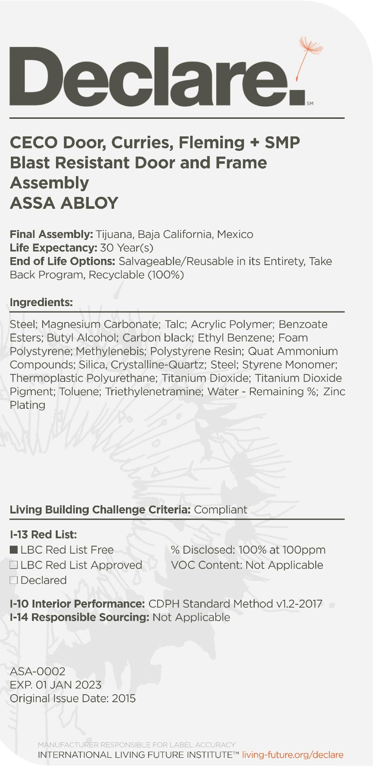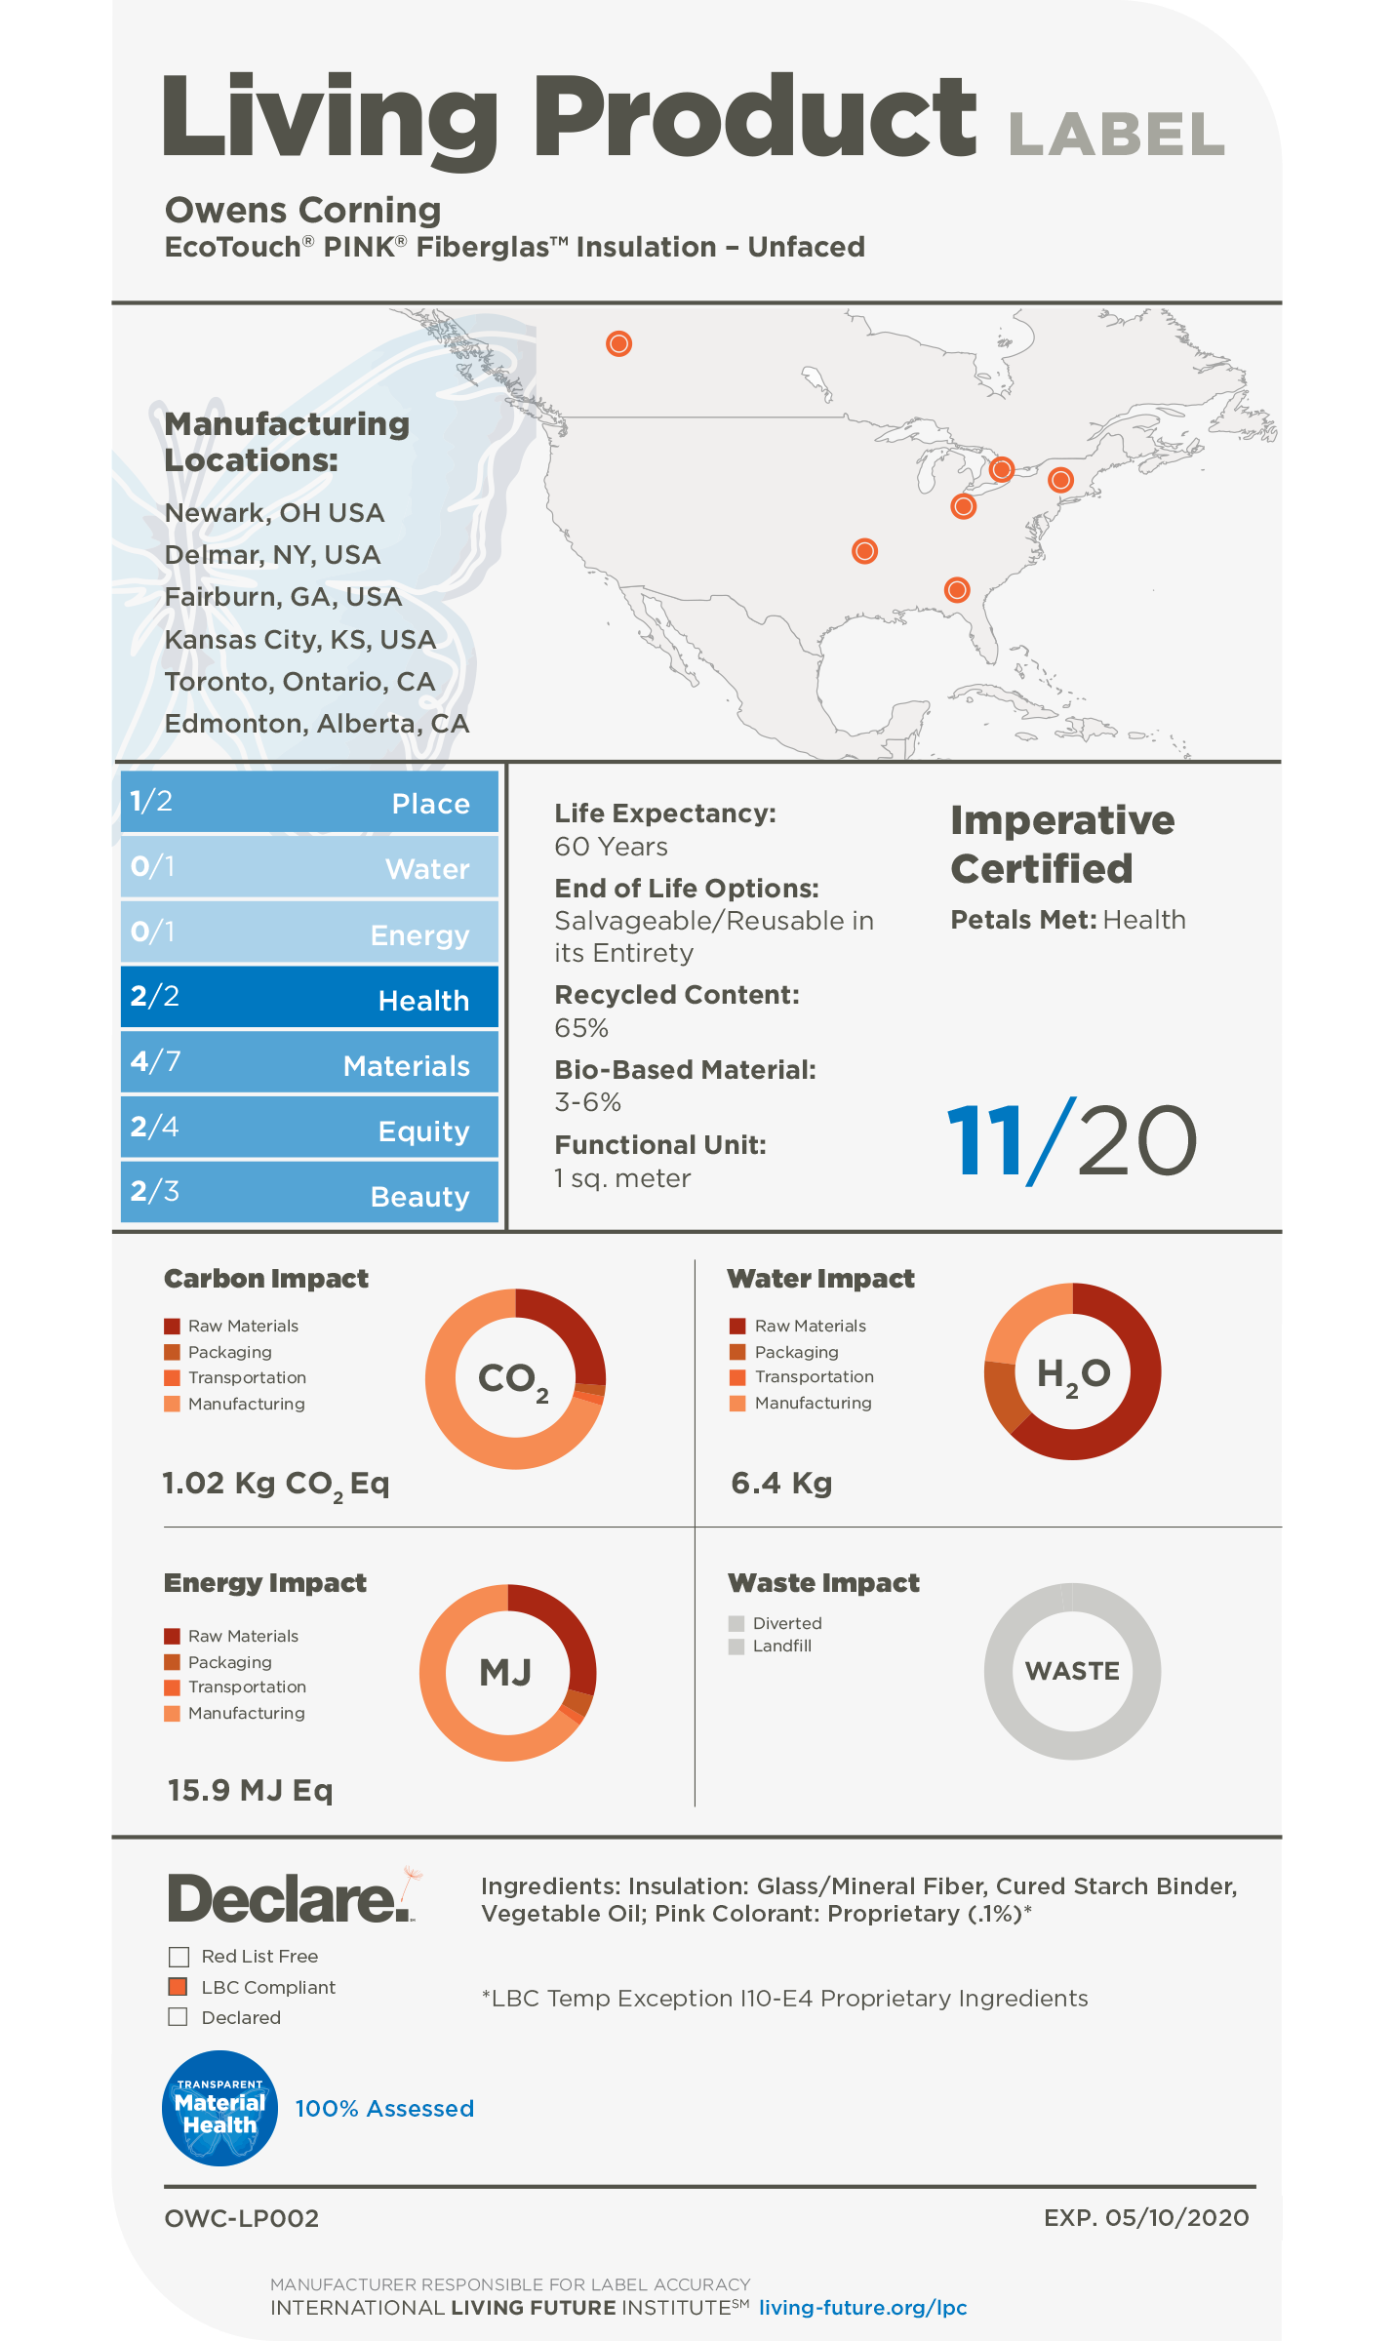
Examples of Third-Party Verified, Public Transparency Documents (Declare and Living Product Challenge Labels)

